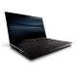  HP PROBOOK 4515S VZ145PA-TM500  13,270,000 VNĐ | 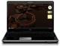  HP Pavilion dv7-2173cl (Intel ...  17,799,000 VNĐ | 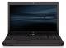  HP PROBOOK 4515S VZ144PA/AM300  12,532,000 VNĐ | 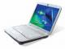  Acer Aspire AS4720-301G16Mn ...  Đang cập nhật..
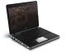  HP Pavilion dv2-1033cl ...  14,200,000 VNĐ | 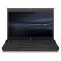  HP ProBook 4410s (VA081PA) ...  12,650,000 VNĐ | 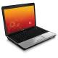  Compaq Presario CQ40-629TU ...  Đang cập nhật.. | 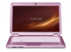  Sony Vaio VGN-CS320J/P (Intel ...  21,006,000 VNĐ
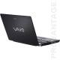  Sony Vaio VGN-SR590GNB (Intel ...  30,536,500 VNĐ | 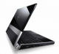  Dell Studio XPS M1640 (Intel ...  21,006,000 VNĐ | 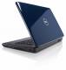  Dell Inspiron 15 (1545) (Intel ...  Đang cập nhật.. | 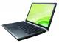  Sony Vaio VGN-SR490PDB (Intel ...  27,424,500 VNĐ
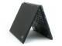  IBM Thinkpad T43 (2668-CTO) ...  5,900,000 VNĐ |   HP Pavilion dv4t (Intel Core ...  13,799,000 VNĐ | 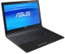  Asus UX50V-RX05 (Intel Core 2 ...  14,625,000 VNĐ | 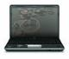  HP Pavilion dv4-1506tu ...  16,550,000 VNĐ
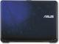  Asus X83VB-X2 (Intel Core 2 ...  9,800,000 VNĐ | 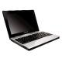  Lenovo Ideapad G230 ...  7,600,000 VNĐ | 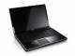  Dell Studio XPS 16 (1640) ...  24,220,000 VNĐ | 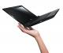  Asus U80V (Intel Core 2 Duo ...  14,400,000 VNĐ

